

**CONSUMER ELECTRONICS**

**EXPERIMENT 2 : Burglar Alarm System**

**Submitted By:**

| Name | UID | Batch | Division |
| --- | --- | --- | --- |
| Adwait Purao | 2021300101 | C | BE COMPS B |
| Rohit Phalke | 2021300100 | D | BE COMPS B |
| Jyoti Bagul | 2022301001 | C | BE COMPS B |

**Submitted To:**

Prof. Milind Paraye

# **Introduction**

This project focuses on designing and simulating a basic burglar alarm system using a 555 timer integrated circuit (IC) configured in monostable mode. The goal is to develop a reliable and straightforward security mechanism that detects unauthorized entry by activating a switch, thereby signaling a potential intrusion. The 555 timer IC, renowned for its versatility and reliability in timing and waveform generation, will be used to drive both a visual indicator (an LED) and an auditory alarm (a buzzer). This experiment not only illustrates practical applications of electronic principles but also showcases how simple components can be effectively combined to address common security concerns.

# **II. Working**

**Components and Connections:**

* 1. **555 Timer IC (A1):**
* Pin 1 (GND): Connected to the ground.
* Pin 2 (TRI - Trigger): Connected to the junction of the switch (S1), resistor (R1), and capacitor (C1).
* Pin 3 (OUT): Connected to the LED (LED1) and buzzer (LS1).
* Pin 4 (RST - Reset): Connected to the power supply (VCC).
* Pin 5 (CON - Control Voltage): Usually connected to ground through a small capacitor (not shown here).
* Pin 6 (THR - Threshold): Connected to the junction of resistor (R2) and capacitor (C1).
* Pin 7 (DIS - Discharge): Connected to one end of resistor R2.
* Pin 8 (VCC): Connected to the positive terminal of the power supply (12V).
  1. **Resistors (R1, R2):**
* R1: 4.1 kΩ, connected between the positive terminal of the power supply and switch S1.
* R2: 5.1 kΩ, connected between Pin 6 and Pin 7 of the 555 timer and to the positive terminal of the power supply.
  1. **Capacitor (C1):** 1 μF, connected between Pin 2 and ground.
  2. **Switch (S1):** Normally open, connected between the resistor R1 and ground.
  3. **LED (LED1):** Connected to the output pin (Pin 3) of the 555 timer through the buzzer (LS1).
  4. **Buzzer (LS1):** Connected in series with the LED and the output pin of the 555 timer.
  5. **Power Supply (V1):** 12V DC.

**Operations:**

1. **Idle State:**

* When the circuit is powered but the switch (S1) is not pressed, the capacitor (C1) is not charged, and the 555 timer's output (Pin 3) remains low.
* The LED and buzzer are off since there is no current flowing through them.

1. **Triggering the Alarm:**

* When the switch (S1) is pressed (which could be triggered by an intruder), it provides a path to ground, discharging the capacitor (C1) and pulling the trigger pin (Pin 2) low.
* The low voltage at the trigger pin activates the 555 timer, causing the output pin (Pin 3) to go high.

1. **Alarm Activation:**

* As the output pin goes high, current flows through the LED (LED1) and the buzzer (LS1), turning them on.
* The buzzer emits sound, and the LED lights up, indicating the alarm is active.

1. **Monostable Mode:**

* The 555 timer in monostable mode means the output will remain high for a certain period, determined by the values of R2 and C1.
* Once the capacitor (C1) charges to a threshold level, the output pin (Pin 3) goes low again, turning off the LED and buzzer.
* The alarm will stay on only for a limited time after S1 is pressed unless it's held down.

# **III. Circuit Simulation**

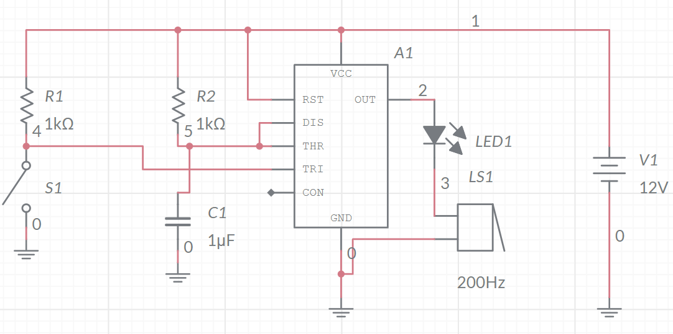

# **IV. Simulation Output**

1. Circuit Off - Switch Disconnected

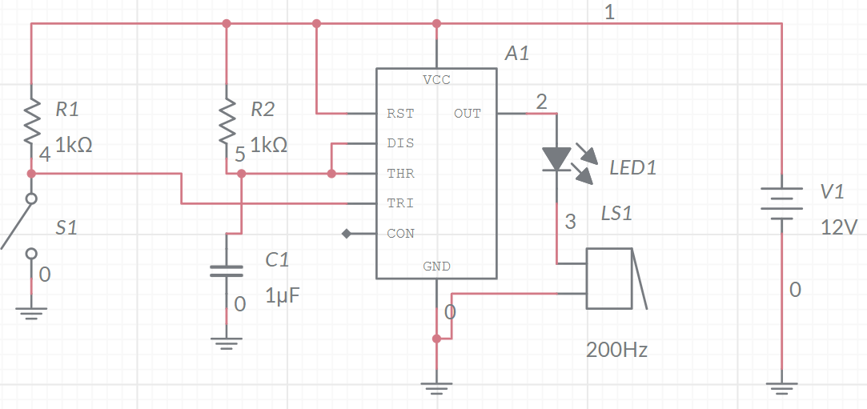

1. Circuit ON- Switch Connected

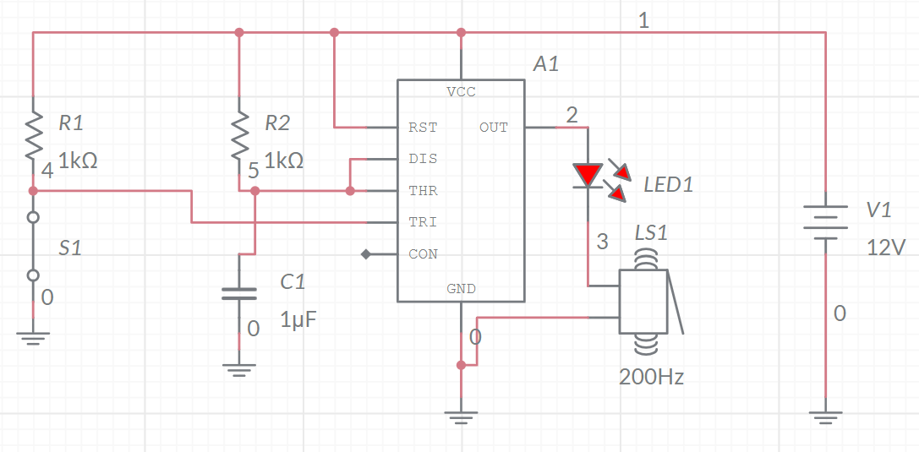

**Burglar Detected**

# **V. Conclusion**

In this experiment, we created and simulated a basic burglar alarm system utilizing a 555 timer IC configured in monostable mode. The circuit detects an intrusion by activating a switch, which prompts the 555 timer to generate a high signal. This signal in turn triggers both an LED and a buzzer to alert the user. The alarm remains active for a predetermined time, based on the resistor and capacitor values, before automatically resetting. This straightforward and cost-effective circuit is ideal for fundamental security applications in homes or small offices, offering reliable detection of unauthorized entry.